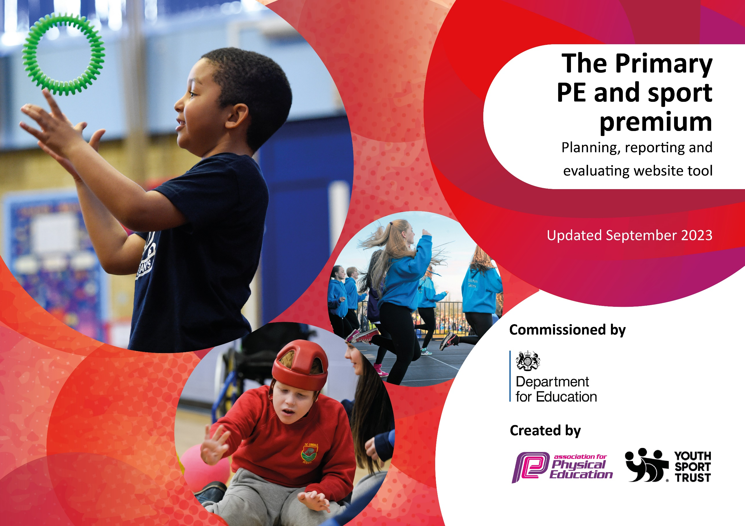

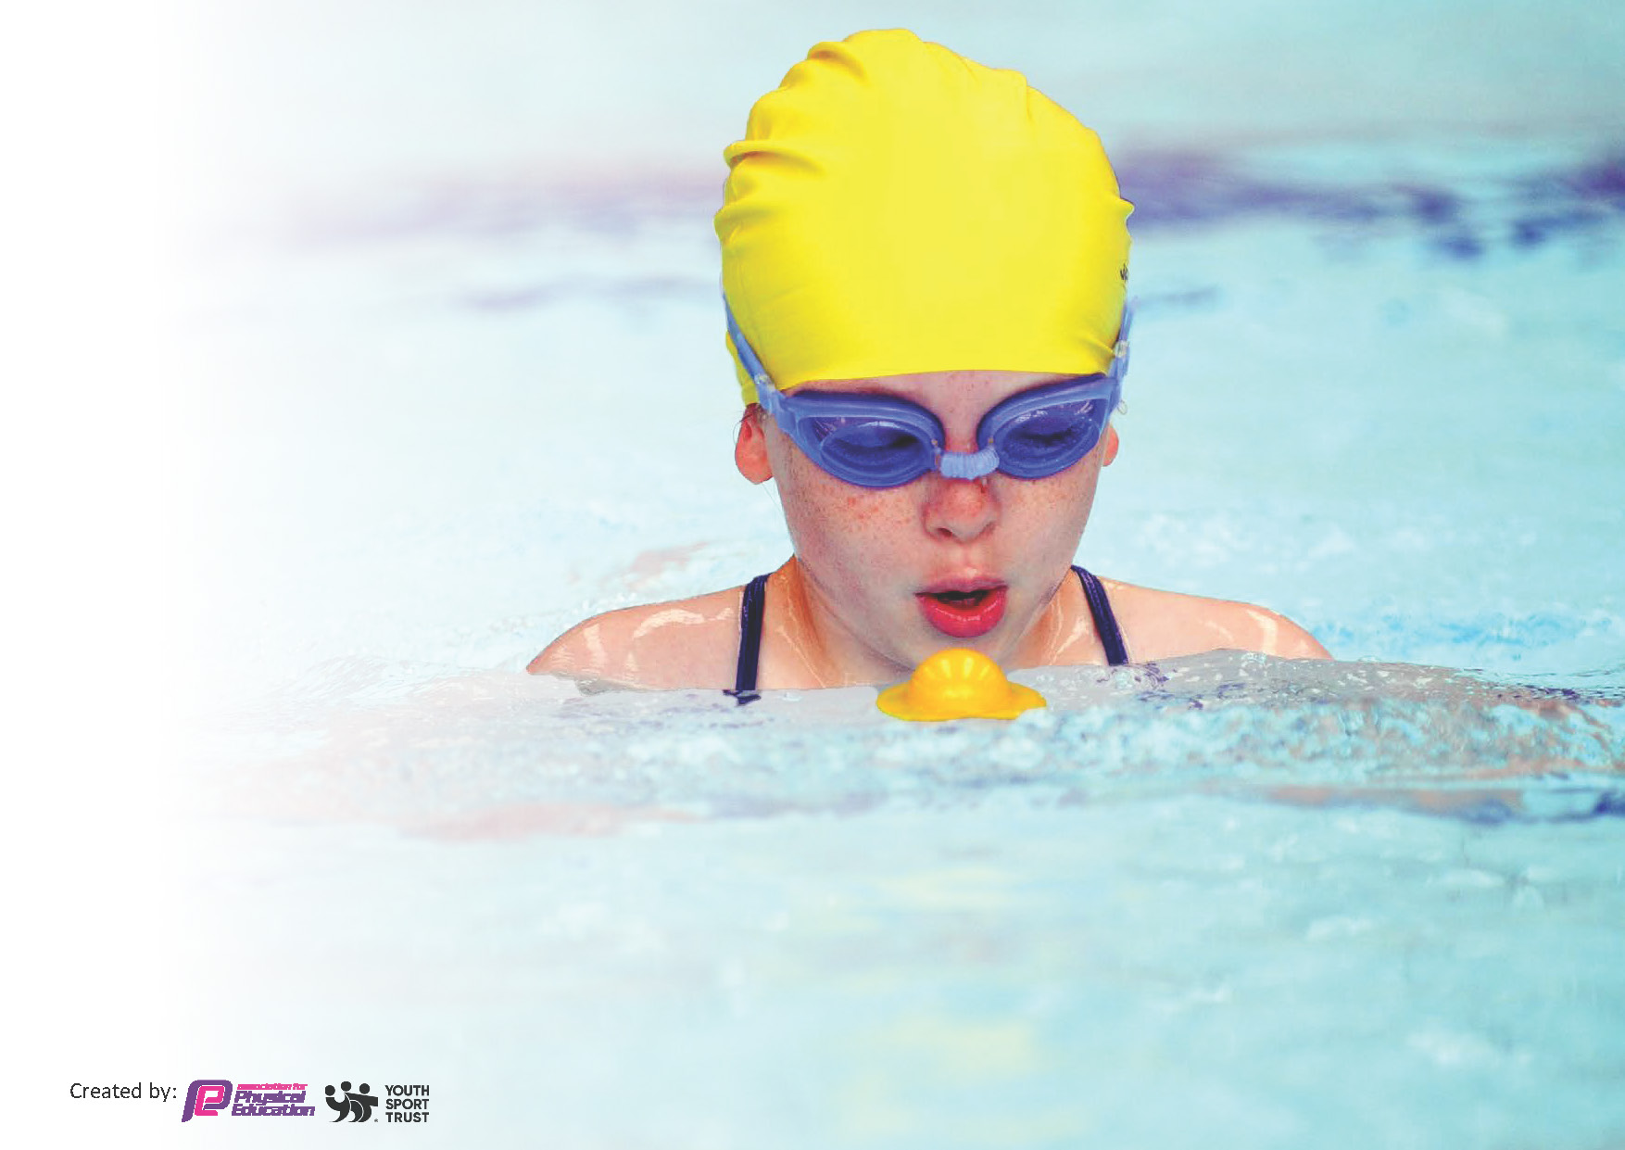
This template can be used for multiple purposes:
by:
- It enables schools to effectively plan their use of the Primary PE and sport premium
- It helps schools to meet the requirements (as set out in guidance) to publish information on their Primary PE and sport premium
- It will be an effective document to support Ofsted inspections enabling schools to evidence progress in Physical Education (PE) and evidence swimming attainment, which forms part of the PE National Curriculum. We would recommend schools consider
the Intent, Implementation and Impact of any spend, as examined within the Education Inspection Framework.

It is important that your grant is used effectively and based on school need.

Schools must use the funding to make additional and sustainable
improvements to the quality of the PE, School Sport and Physical Activity (PESSPA)
they offer. This means that you should use the Primary PE and sport premium to:

- Build capacity and capability within the school to ensure that improvements made now will benefit pupils joining the school in future years
- Develop or add to the PESSPA activities that your school already offers.

The Primary PE and sport premium should not be used to fund capital spend projects; the school’s core budget should fund these. Further detail on capital expenditure can be found in the updated Primary PE and sport premium guidance.

The Primary PE and sport premium guidance, outlines 5 key priorities that funding should be used towards. It is not

necessary that spending has to meet all the key priorities, you should select the priorities that you aim to use any funding towards.

Although completing this template is not a requirement for schools, schools are required to publish details of how they spend this funding. Schools must also outline what the impact this funding has had on pupils’ PE and sport participation and attainment and how any spending will be sustainable in the future. All funding must be spent by 31st July 2024.

The Department for Education has worked closely with the Association for Physical Education (afPE) and the Youth Sport Trust (YST) to develop this template and encourages schools to use it. This template is an effective way of meeting the reporting requirements of the Primary PE and sport premium.
Review of last year’s spend and key achievements (2023/2024)

We recommend you start by reflecting on the impact of current provision and reviewing your previous spend.

Activity/Action | Impact | Comments
Active fusion to support the structured PE curriculum and unstructured times eg lunchtime sports club for KS1/2 provision.  Add new PE equipment and replace old equipment.  Inter/Intra school sporting fixtures | - PE curriculum delivery shows ALL KS2 pupils making at least expected or above progress in Autumn/ Spring/ Summer  - Improved fundamental skills  - Increased confidence to try new skills and develop their existing knowledge.  - Attendance of KS2 pupils to lunchtime clubs to enhance their skills in sporting activities, improve fitness and reduce poor behavior.  - Fusion playground leaders successfully introduced in Summer with pupils achieving the award.  - Updated sports equipment has improved pupils access to a variety of new and existing sporting activities.  - Improvement in pupils knowledge and sequences of learning in PE and sport leading to better PE outcomes  - A reduction in behaviour incidents at unstructured times.  - Improved confidence and self-esteem.  - Positive play and cooperation amongst peers.  - Compete in a variety of sporting events.  - Improved confidence and self esteem in social situations and sporting games.  - Improved ability to apply learnt skills in different competitive context.  - Placed 4th In SEN Yorkshire table cricket finals out of the 10 qualified schools (who had to qualify in their own regional finals).  - Cultural capital –sports leaders developed their communication, organisation, planning/ delivery, problem solving when supporting NEXUS sports day. | Active Fusion have been instrumental in supporting the delivery of PE to KS2 pupils and this reflects positively across the school. They have helped pupils embed key fundamental skills that are essential for their development in PE and sport.  In addition, we have introduced the playground leaders successfully and hope to build on this next academic year 24/25.  Look to utilise their resources to offer sporting opportunities in the community/ clubs.  Look to add PE equipment that can be used to support interventions and unstructured times for young pupils.  Having new equipment has helped to introduce new sports/ games eg table cricket.  Continue to build sporting links and creating opportunities for pupils to compete in fun/ competitive games/competitions.

Key priorities and Planning
This planning template will allow schools to accurately plan their spending.

Action – what are you planning to do | Who does this action impact? | Key indicator to meet | Impacts and how sustainability will be achieved? | Cost linked to the action  £16,170 Sports Premium Fund 2024/25
Delivery of high-quality PE lessons to KS2 pupils.  Active Fusion support the delivery of awards eg Fusion playground leaders award.  Supporting lunchtime sports/activities. | Active Fusion Coaches - they will need to lead the PE & Sports activities. | Key indicator 2: The engagement of all pupils in regular physical activity –– the Chief Medical Officer guidelines recommend that all children and young  people aged 5 to 18 engage in at least 60  minutes of physical activity per day, of which 30 minutes should be in school.  Key indicator 3: The profile of PESSPA being raised across the school as a tool for whole school improvement.  Key indicator 4: Broader experience of a range of sports and activities offered to all pupils | More pupils meeting their daily physical activity goal, more pupils encouraged to take part in PE and Sport Activities. | Cost of Active Fusion coach  1 day per week  £8312
Purchase new PE equipment to support the delivery of high-quality PE lessons/PE curriculum.  In addition, to enhance PE and Sports at unstructured times eg breaktimes/  lunchtimes.  To offer an afterschool club  provision for all  pupils. | PE lead/ Coach– will have access to a wide range of sporting equipment to support the delivery of the PE PVS curriculum.  Pupils – Will be able to use to develop and improve their skills in PE and Sport.  Pupils - as they will take part in fun play and improve their fundamental skills. These are essential and lay the foundation for an active lifestyle, long-term health, and more complex skills.  Pupils – Pupils will have access  to increased physical activity  opportunities. | Key indicator 3: The profile of PESSPA being raised across the school as a tool for whole school improvement.  Key indicator 3: The profile of PESSPA being raised across the school as a tool for whole school improvement. | PE lead/Coach can deliver high quality PE lessons through sequential lessons. Pupils will develop their skills and knowledge in PE & Sport through sequence and layers of learning. | Purchase equipment £4858  Breakdown of costing:  £621.35 sports directory UK purchase of sports equipment for Acorn class.  £253.20 sports directory uk  £ 858 for equipment and  resources to support  inclusive physical activity  that all pupils can access  on a regular basis.  purchase  Part of the Active Fusion package.
To offer CPD sessions throughout the  year in order to improve the ethos of PE and to ensure that inclusive practice takes place. | Staff – Upskill support staff in support in PE and Sport across the school. Be able to deliver sporting activities at unstructured times.  CPD to NEXUS PE leads Feb 25 – Table Cricket. | Key indicator 1: Increased confidence, knowledge and skills of all staff in teaching PE and sport
Pupils to experience  sports events and  activities. | Pupils – To take part in a broad range of activities and build upon existing skills and knowledge in sports. Opportunity to experience new sporting activities  Martial Arts – SSMA Kickboxing sessions Jan – March | Key indicator 4: Broader experience of a range of sports and activities offered to all pupils | Pupils will be able to  experience new sports  and activities and experience  lasting memories. | Cost of external providers and facilities £2000
Pupils to access internal house competitions and external sporting fixtures and events over the calendar year. | Pupils – they will be able to  take part in healthy  competition and sporting experiences. | Key indicator 5: Increased participation in competitive sport | Pupils have experienced inter house competition with  others eg house football remembers.  Sports Day May 25  External sporting fixtures. Stonehill Football event/ NEXUS Sports day. | Costs £1000

Key achievements 2024-2025
This template will be completed at the end of the academic year and will showcase the key achievements schools have made with their Primary PE and sport premium spending.

Activity/Action | Impact | Comments

Swimming Data
Meeting National Curriculum requirements for swimming and water safety.
Priority should always be given to ensuring that pupils can perform safe self-rescue even if they do not fully meet the first two requirements of the National Curriculum programme of study

Question | Stats: | Further context  Relative to local challenges
What percentage of your current Year 6 cohort can swim competently, confidently and proficiently over a distance of at least 25 metres? | %  Swimming to commence January 7th – 25th March (12 weeks)  Tuesdays  Hazel – 9.15-10.15am  Acorn – 10.15 – 11.15am | Use this text box to give further context behind the percentage.  e.g., 30% - we are struggling to get pool space due to our local pool closing so we have had to use a much smaller local school pool. We have had to limit the number of pupils attending swimming lessons during one term which means some pupils have attended fewer swimming lessons than others.
What percentage of your current Year 6 cohort can use a range of strokes effectively [for example, front crawl, backstroke, and breaststroke]? | % | Use this text box to give further context behind the percentage.  e.g., Even though your pupils may swim in another year please report on their attainment on leaving primary school at the end of the summer term 2024

What percentage of your current Year 6 cohort are able to perform safe self-rescue in different water-based situations? | % | Use this text box to give further context behind the percentage.
If your schools swimming data is below national expectation, you can choose to use the Primary PE and sport premium to provide additional top-up sessions for those pupils that did not meet National Curriculum  requirements after the completion of core lessons. Have you done this? | Yes/No
Have you provided CPD to improve the knowledge and confidence of staff to be able to teach swimming and water safety? | Yes/No

Signed off by:

Head Teacher: | (Name)
Subject Leader or the individual responsible for the Primary PE and sport premium: | (Name and Job Title)
Governor: | (Name and Role)
Date:

