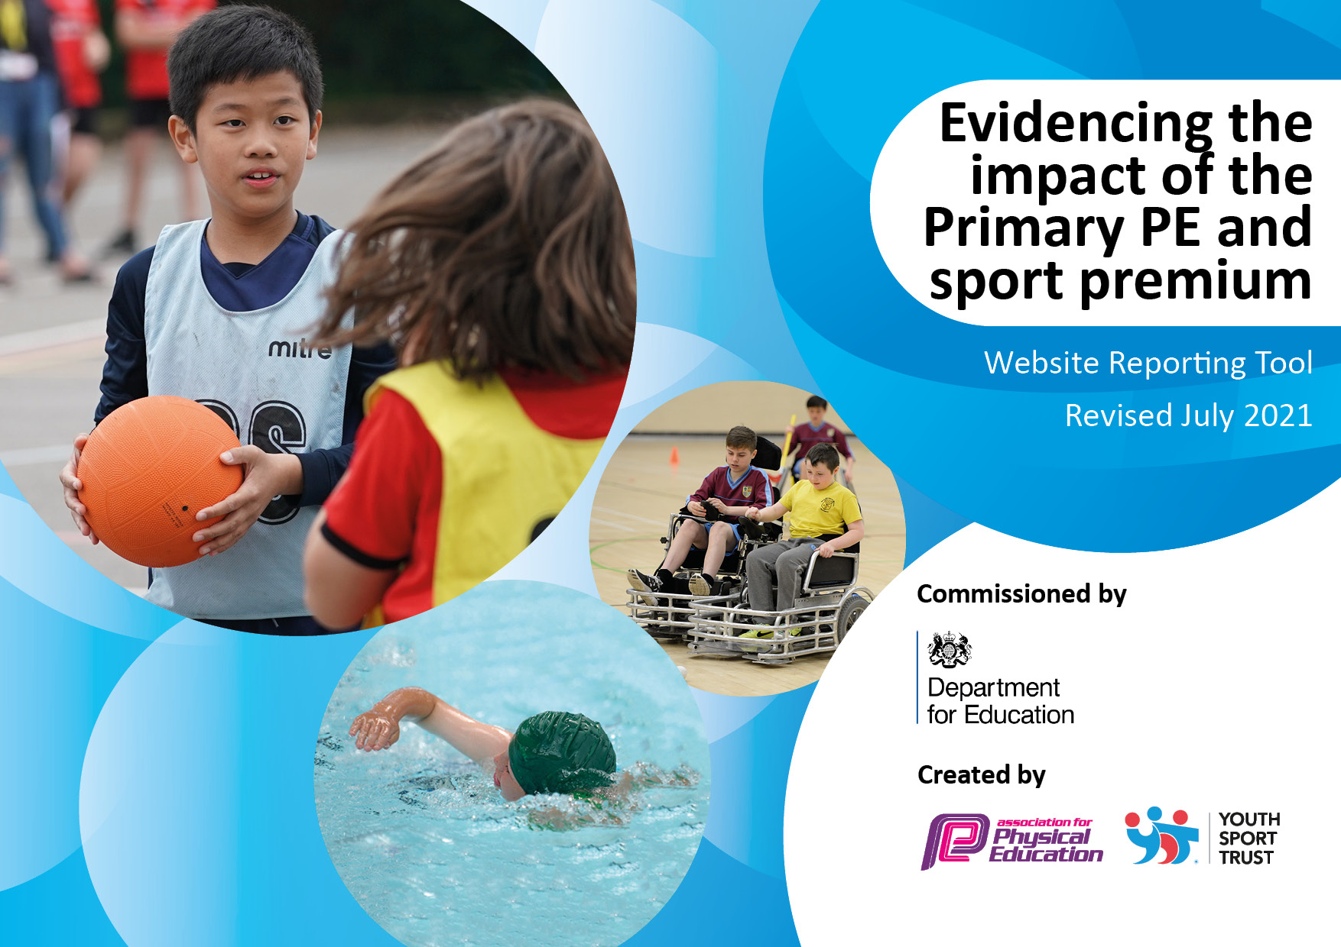
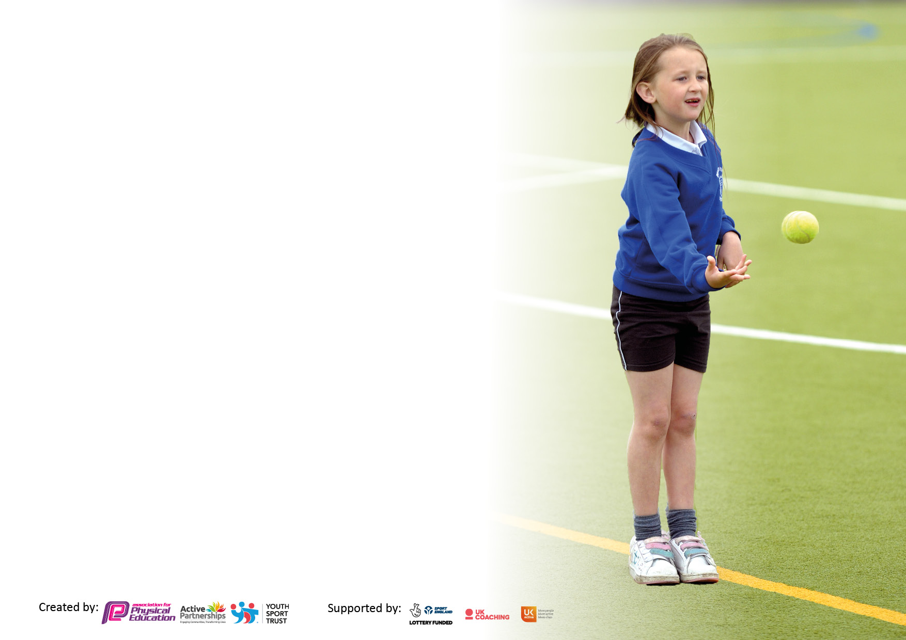

It is important that your grant is used effectively and based on school need. The Education Inspection Framework makes clear there will be a focus on ‘whether leaders and those responsible for governors all understand their respective roles and perform these in a way that enhances the effectiveness of the school’.

Under the Quality of Education Ofsted inspectors consider:
Intent - Curriculum design, coverage and appropriateness
Implementation - Curriculum delivery, Teaching (pedagogy) and Assessment
Impact - Attainment and progress

To assist schools with common transferable language this template has been developed to utilise the same three headings which should make your plans easily transferable between working documents.

Schools must use the funding to make additional and sustainable improvements to the quality of Physical Education, School Sport and Physical Activity (PESSPA) they offer. This means that you should use the Primary PE and sport premium to:

- Develop or add to the PESSPA activities that your school already offer
- Build capacity and capability within the school to ensure that improvements made now will benefit pupils joining the school in future years
- The Primary PE and sport premium should not be used to fund capital spend projects; the school’s budget should fund these.

Pleasevisitgov.ukfortherevisedDfEguidanceincludingthe5keyindicatorsacrosswhichschoolsshoulddemonstrate animprovement.Thisdocumentwillhelpyoutoreviewyourprovisionandtoreportyourspend.DfEencouragesschools to use this template as an effective way of meeting the reporting requirements of the Primary PE and sport premium.

We recommend you start by reflecting on the impact of current provision and reviewing the previous spend.

Schools are required to publish details of how they spend this funding, including any under-spend from 2019/2020, as well as on the impact it has on pupils’ PE and sport participation and attainment. All funding must be spent by 31st July 2022.

We recommend regularly updating the table and publishing it on your website throughout the year. This evidences your ongoing self-evaluation of how you are using the funding to secure maximum, sustainable impact. Final copy must be posted on your website by the end of the academic year and no later than the 31st July 2021. To see an example of how to complete the table please click HERE.
Created by: Supported by:

Details with regard to funding
Please complete the table below.

Total amount carried over from 2019/20 | £0
Total amount allocated for 2020/21 | £16250
How much (if any) do you intend to carry over from this total fund into 2021/22? | £0
Total amount allocated for 2021/22 | £16,500
Total amount of funding for 2021/22. To be spent and reported on by 31st July 2022. | £16,500
Swimming Data
Please report on your Swimming Data below.

Meeting national curriculum requirements for swimming and water safety.  N.B. Complete this section to your best ability. For example you might have practised safe self-rescue techniques on dry land which you can then transfer to the pool when school swimming restarts.  Due to exceptional circumstances priority should be given to ensuring that pupils can perform safe self rescue even if they do not fully meet the first two requirements of the NC programme of study | To be completed 2022.  Barn Owl/ Tawny Owl  21/4/22 – 14/7/22
What percentage of your current Year 6 cohort swim competently, confidently and proficiently over a distance of at least 25 metres?  N.B. Even though your pupils may swim in another year please report on their attainment on leaving primary school at the end of the summer term 2022.  Please see note above | 8.33%
What percentage of your current Year 6 cohort use a range of strokes effectively [for example, front crawl, backstroke and breaststroke]?  Please see note above | 30 %
What percentage of your current Year 6 cohort perform safe self-rescue in different water-based situations? | 0%
Schools can choose to use the Primary PE and sport premium to provide additional provision for swimming but this must be for activity over and above the national curriculum requirements. Have you used it in this way? | No (Focus for 2022/23)

Action Plan and Budget Tracking
Capture your intended annual spend against the 5 key indicators. Clarify the success criteria and evidence of impact that you intend to measure to evaluate for pupils today and for the future.

Academic Year: 2020/21 | Total fund allocated:  £16,500 | Date Updated:  12/12/21
Key indicator 1: The engagement of all pupils in regular physical activity – Chief Medical Officers guidelines recommend that primary school pupils undertake at least 30 minutes of physical activity a day in school |  |  |  | Percentage of total allocation:
 |  |  |  | 72.7%
Intent | Implementation |  | Impact
Your school focus should be clear what you want the pupils to know and be able to do and about  what they need to learn and to  consolidate through practice: | Make sure your actions to achieve are linked to your intentions: | Funding allocated: | Evidence of impact: what do pupils now know and what can they now do? What has changed?: | Sustainability and suggested next steps:
Opportunities in place to ensure all  pupils undertake 30 minutes of activity a day in school.  Ensure more pupil who are less active engage in 30 minutes activity a day.  Improve pupils physical health and wellbeing through the development of the outdoor lower school provision.  Improve pupil’s lifelong health and wellbeing through the Evolve health mentors’ provision. | - All pupils have timetable access to the daily mile track to take part in their daily mile walk, jog or run.  - Pupils have opportunity to attend one of the lunchtime clubs with different sports activities each day.  - Sport activities set up and supervised by pupil playtime supervisors and teaching staff.  - Support the provision of break and lunchtimes clubs. Doncaster foundation coaches continue to deliver high quality teaching of PE to pupils in lower school.  - Activities and videos shared with pupils through ClassDojo and home learning to promote physical activity.  - Ensure a sustainable provision for current and future pupils that is age appropriate and maps out the projected plans.  - Pupils are briefed on the outdoor equipment and the adults model how to use the equipment safely.  - Active play opportunities for pupils is in abundance and the benefits of this are discussed with pupils often.  - Access to the outdoor learning is daily either during practical lessons or during break and lunchtimes.  - Implement ‘Evolve’ high impact programme and deeply embed its work within the lower school classes.  - Pupils to work closely with health mentors to develop their physical, emotional and cognitive skills.  - Feedback on pupil progress to be given to SLT. | £ 3000  £4500  £2,000 | - Pupils improved fitness levels and ability to maintain their effort for longer periods of time.  - The Daily Mile is part of the daily routine for most classes during form time.  - Enriched lunchtimes and breaktimes have been extremely successful. Pupils are more confident and enjoy taking part in the variety of activities on offer. Behaviour has improved significantly during unstructured times.  - Staff awareness of the importance of playtime and classroom activity and learning breaks.  - Pupils actively participate in unstructured times  - Home-school engagement in physical activity.  - Pupils improved physical health and wellbeing.  - An improvement in pupils’ fundamental skills.  - All pupils enjoy actively exploring the equipment and using it through active play.  - A sustainable play area that will be long lasting for future pupils.  - Pupils improved physical health and wellbeing.  - Pupils enjoy taking part in activities and feel much more confident.  - Improved social skills and empathy.  - Developing resilience and a can do attitude. | - Look to implement whole school daily mile challenges.  - Continue to use ‘pupil voice’ to tailor their interests and further enhance the provision of physical activity at break and lunchtimes.  - Continue to support teaching assistants with their provision of clubs.  - Engage parents through posting website links and activities through Doncaster Foundation.  - Monitor the impact of the pupils going forward.  - Use ‘pupil voice’ to develop the outdoor space.  - Use the outdoor space for PE specific lessons.  - Continue to build upon opportunities for pupils to take part in creative play eg social situation like sharing.  - Opportunities to continue the provision to other classes.  - Ideas and activities used by Evolve to be shared amongst staff or possible CPD opportunity.

Key indicator 2: The profile of PESSPA being raised across the school as a tool for whole school improvement |  |  |  | Percentage of total allocation:
 |  |  |  | 15.1%
Intent | Implementation |  | Impact
Your school focus should be clear what you want the pupils to know and be able to do and about  what they need to learn and to  consolidate through practice: | Make sure your actions to achieve are linked to your intentions: | Funding allocated: | Evidence of impact: what do pupils now know and what can they now do? What has changed?: | Sustainability and suggested next steps:
PE and school sport is visible and celebrated in the school (assemblies, PE notice boards, trophy cabinet, school website, local press, pupil rewards/ Dojo and recognition of pupils)  Pennine View is considered a sports/active school that encourages all pupils to engage in PE, Sports and physical activity. PE and Sports continues to be a strength and to support this equipment needs to be replaced and updated.  Continue to access the Doncaster foundation sports package. | - School celebration assembly raises the profile of our pupils’ achievements in PE and sport in school eg. PE in action photos or PE awards.  - Continue to celebrate success with the ‘Sports Star’ award in PE lessons.  - Regularly updating sporting achievements on class Dojo to encourage pupils to share their progress and develop sporting conversations across school and home.  - Carry out the community sports festival event to raise the profile of PE and sport at school.  - Replace and update equipment to support PE and sports provision at school. This will ensure high quality PE and sports can be delivered and pupils can use the equipment to develop and improve their skills and physical literacy.  - Offer pupils and their family’s resources to support PE and sports participation. E.g. Doncaster Rovers tickets to game, Mascot visit.  - Doncaster Foundation coaches raising the profile of PE and sport across the school in their active roles. | £3500  £1500 | - PE physical activity and school sport have a high profile and are celebrated across the life of the school.  - Pupils like to showcase their successes in PE and sport.  - Pupils developed skills and physical literacy.  - School and Home links to PE and Sports improved.  - Pupils have access to a wide range of equipment to increase participation, activity and the opportunity to develop skills. The equipment supports a breadth of PE and sports being provided across the school and break and lunchtimes.  - Pupil enjoyed going to watch a live Doncaster Rovers game with their family.  - Positive links with families and the sports partnership.  - Improved skills and physical literacy. | - Continue to update displays and recognition of PE and sport across the school.  - Invite local sporting heroes in to school. Eg Q&A session or deliver a session.  - Continue to improve the PE equipment and resources to maintain high quality PE and sports across the school.  - Utilise the player visit and stadium tour when not in school Covid protocol.

Key indicator 3: Increased confidence, knowledge and skills of all staff in teaching PE and sport |  |  |  | Percentage of total allocation:
 |  |  |  | 6.1%
Intent | Implementation |  | Impact
Your school focus should be clear | Make sure your actions to | Funding | Evidence of impact: what do | Sustainability and suggested
what you want the pupils to know | achieve are linked to your | allocated: | pupils now know and what | next steps:
and be able to do and about | intentions: |  | can they now do? What has
what they need to learn and to |  |  | changed?:
consolidate through practice:
A continuation of good training and developing staff skills and confidence through modelled teaching by the PE coordinator and Doncaster Foundation Coaches.  Further CPD opportunities supported by Doncaster foundations to increase the confidence and the skills of staff to run sporting activities and games at unstructured times (break/lunch). | - Support staff continue to be part of the whole school PE provision delivered by PE coordinator and Doncaster foundation coaches. They take an active role within the lesson e.g lead a small group or collaborate with the lead teacher in the assessment process.  - Staff training for lunchtime supervisors to ensure play is  - constructive and active at break and lunchtimes. | £1000 | - Support staff feel more confident in their ability to support a PE and sports lesson. They feel they have a better knowledge and understanding of the skills and laws of the sports activities. Staff have an improved understanding of how a PE/Sports lesson is carried out and can readily give a judgement on the performance of a pupil when referring to their PE targets.  - Lunchtime staff have increased their knowledge and confidence to lead playtime activities, resulting in positive behaviour during unstructured times. This has given lunchtime supervisors more confidence to know the pupil and the pupil feel they can approach the staff more. | - Increase staff CPD through Doncaster Foundation.  - Use staff survey to identify gaps  - in knowledge and effectively plan  - support to improve these areas.

Key indicator 4: Broader experience of a range of sports and activities offered to all pupils |  |  |  | Percentage of total allocation:
 |  |  |  | 6.1%
Intent | Implementation |  | Impact
Your school focus should be clear | Make sure your actions to | Funding | Evidence of impact: what do | Sustainability and suggested
what you want the pupils to know | achieve are linked to your | allocated: | pupils now know and what | next steps:
and be able to do and about | intentions: |  | can they now do? What has
what they need to learn and to |  |  | changed?
consolidate through practice:
Continue to develop the range and  breadth of sports offered so pupils  engage in sport on a regular basis and try  new sports.  School continues to offer a wide range of  sports ensuring all pupils participate in  a range of sports led by high quality  teaching.  Sports coaches from Doncaster Foundation offering a breadth of sports and activities in lessons and unstructured times (break/lunchtimes) | - Whole school sporting events and competitions have taken place in school specifically targeted to encourage inclusivity and ensure everyone has the opportunities to take part in and develop their sporting interests. Engagement of parents/carers at these events has been successful.  - Lunchtimes clubs have been set up to encourage pupils to try new sports and activities. These also link into current topics delivered in PE to further develop and refine skills and knowledge within PE and sport. Pupil voice will be used to focus on areas of interest from our pupils. This provision is supported by Doncaster Foundation coaches. | £500  £500 | - Feedback from ‘pupil voice’ and parents/carers via Dojo has been positive.  - Attendance of parents/carers to sporting events eg. Community sports festival at an all time high. This shows the support from parents/carers for their child and PE and sports.  - Pupils speak highly of the lunchtime clubs on offer and enjoy using different sports  - equipment and partaking in  - structured games at lunch times. This has also had a positive impact on behaviour around school.  - Communication is underway to reintroduce pathways into community clubs. | - Use the pupil voice to further improve the experience of pupils within PE and sport. Eg add new activity suggestions pupils would like to do.  - Continue to monitor the impact lunchtime sports clubs have on our pupils and improve where needed.  - Look to offer an afterschool sports club.

Key indicator 5: Increased participation in competitive sport |  |  |  | Percentage of total allocation:
 |  |  |  | 0 %
Intent | Implementation |  | Impact
Your school focus should be clear | Make sure your actions to | Funding | Evidence of impact: what do | Sustainability and suggested
what you want the pupils to know | achieve are linked to your | allocated: | pupils now know and what | next steps:
and be able to do and about | intentions: |  | can they now do? What has
what they need to learn and to |  |  | changed?:
consolidate through practice:
Continue to offer the wide range of competitions in school so pupils learn how to enjoy competition/ be competitive and take this into life outside school.  Sport is seen as valuable and celebrated. More pupils are involved in competitive sports.  Attend the PE pyramid between SEN schools to map out hosting and attending sporting events and fixtures. | - Pupils continue to be celebrated during assemblies each Friday for their achievements so that they feel recognised for their participation.  - Trophies and photographs continue to be displayed around school to promote engagement in sports participation.  - A broad range of sporting opportunities for all pupils have been offered, particularly focussing on increasing participation for our pupils through intra/ inter school competitions and active challenges through sporting events and fixtures.  - PE pyramid meeting has reignited links between our academy and wider SEN school within the community to lead proactive sporting opportunities for our schools  · Willows and Abbey – Spring (KS4)  · Stone Hill and Pennine View – Spring  Summer (KS3)  · North Ridge and Coppice – Summer 1 / 2 (KS2) |  | - Pupils able to celebrate success in sport with peers in a positive manner and demonstrate good sportsmanship values. ‘Healthy competition ethos’.  - Updated displays and awards.  - Pupils enjoyed interacting positively with others pupils and improving their social skills.  - Pupils showed resilience and determination to succeed.  - Development of skills in a game situation.  - Opportunity to improve sportsmanship and gain healthy competition experience.  - Links with others school re-established. | - Continue to highlight the sporting achievements of our pupils and showcase this around the school.  - Make links with local sporting role models and stars within the community to present awards and ‘talk sport’ to our pupils.  - Continue to host and attend sporting fixtures for a wide range of activities for our pupils.  - Re-establish the attendance of whole school sports events eg Athletics disport.

Signed off by
Head Teacher: | Sarah Mulhall
Date: | 19/07/2022
Subject Leader: | James Burns
Date: | 15.07.2022
Governor: | Emma Heyes
Date: | 10/07/2022

