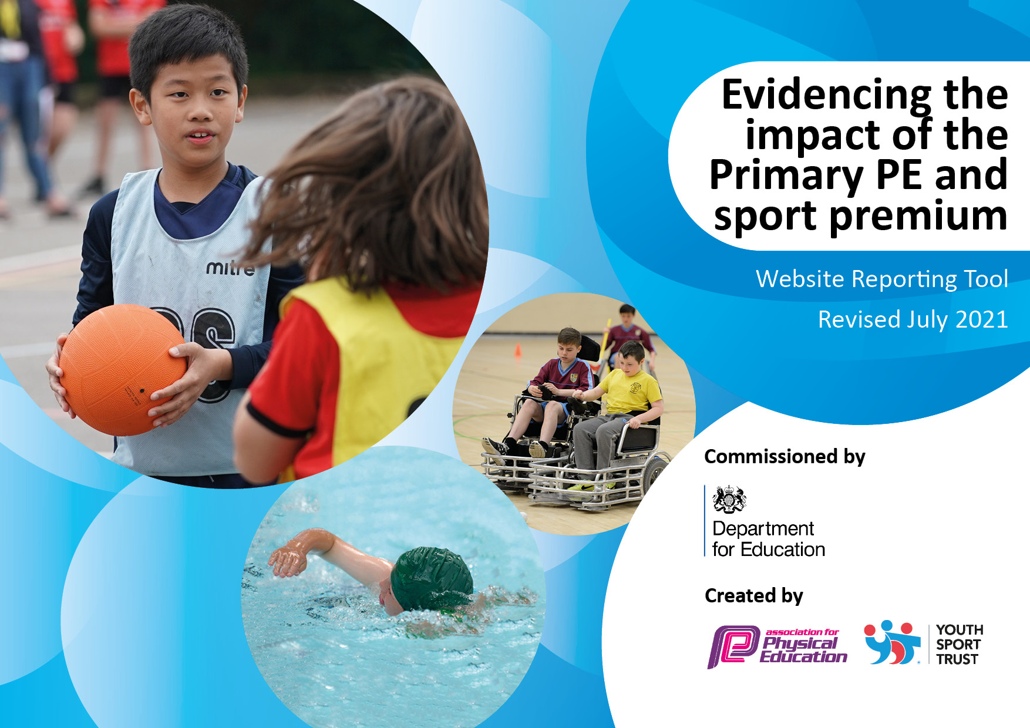
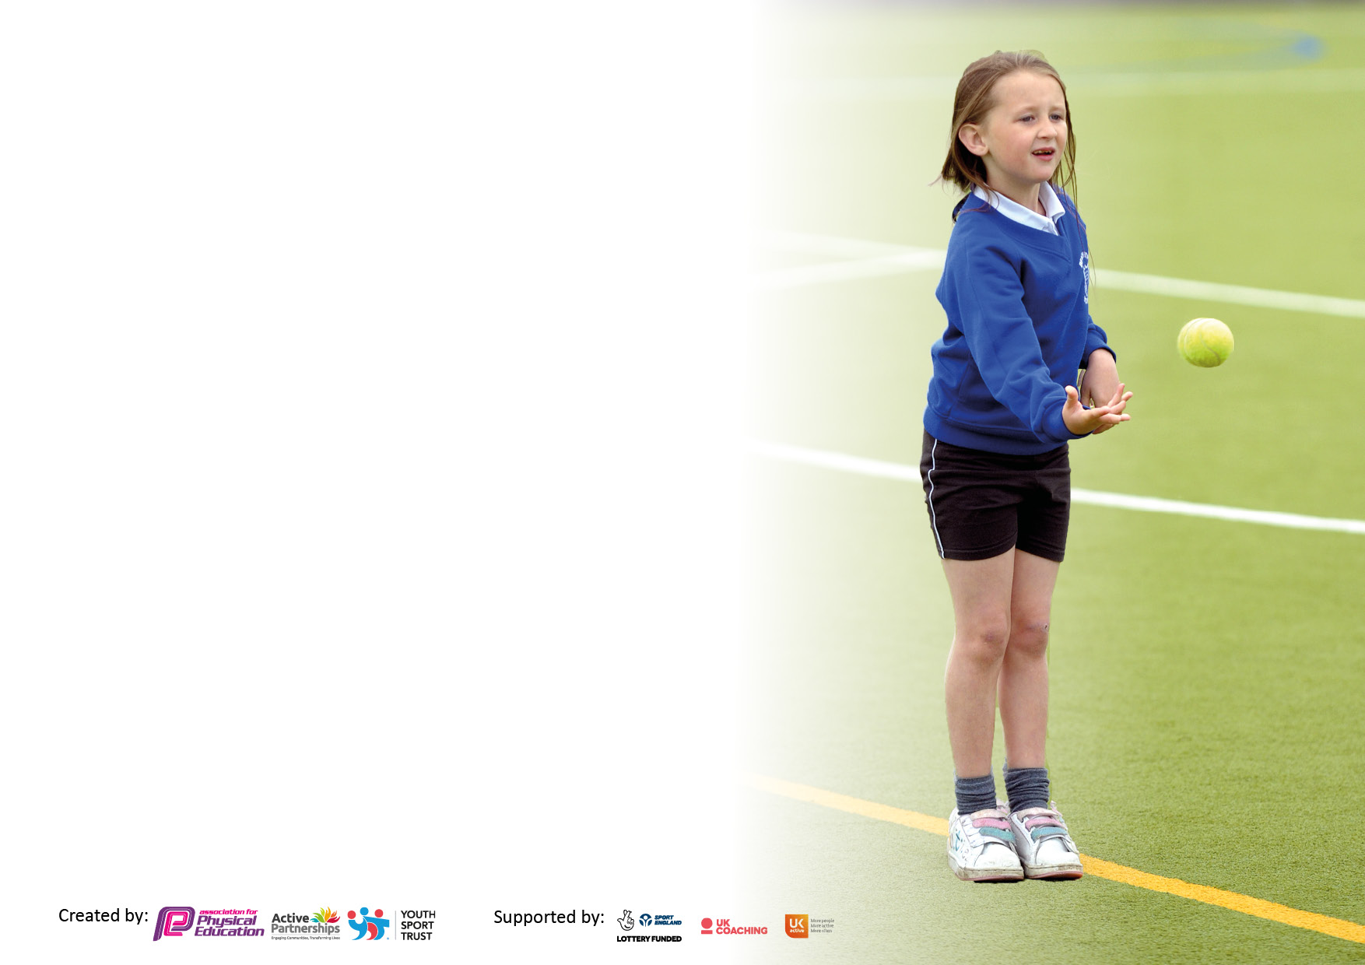

It is important that your grant is used effectively and based on school need. The Education Inspection Framework makes clear there will be a focus on ‘whether leaders and those responsible for governors all understand their respective roles and perform these in a way that enhances the effectiveness of the school’.

Under the Quality of Education Ofsted inspectors consider:
Intent - Curriculum design, coverage and appropriateness
Implementation - Curriculum delivery, Teaching (pedagogy) and Assessment
Impact - Attainment and progress

To assist schools with common transferable language this template has been developed to utilise the same three headings which should make your plans easily transferable between working documents.

Schools must use the funding to make additional and sustainable improvements to the quality of Physical Education, School Sport and Physical Activity (PESSPA) they offer. This means that you should use the Primary PE and sport premium to:

- Develop or add to the PESSPA activities that your school already offer
- Build capacity and capability within the school to ensure that improvements made now will benefit pupils joining the school in future years
- The Primary PE and sport premium should not be used to fund capital spend projects; the school’s budget should fund these.

Pleasevisitgov.ukfortherevisedDfEguidanceincludingthe5keyindicatorsacrosswhichschoolsshoulddemonstrate animprovement.Thisdocumentwillhelpyoutoreviewyourprovisionandtoreportyourspend.DfEencouragesschools to use this template as an effective way of meeting the reporting requirements of the Primary PE and sport premium.

We recommend you start by reflecting on the impact of current provision and reviewing the previous spend.

Schools are required to publish details of how they spend this funding, including any under-spend from 2019/2020, as well as on the impact it has on pupils’ PE and sport participation and attainment. All funding must be spent by 31st July 2022.

We recommend regularly updating the table and publishing it on your website throughout the year. This evidences your ongoing self-evaluation of how you are using the funding to secure maximum, sustainable impact. Final copy must be posted on your website by the end of the academic year and no later than the 31st July 2021. To see an example of how to complete the table please click HERE.
Created by: Supported by:

Details with regard to funding
Please complete the table below.

Total amount carried over from 2019/20 | £0
Total amount allocated for 2020/21 | £16250
How much (if any) do you intend to carry over from this total fund into 2021/22? | £0
Total amount allocated for 2021/22 | £16,500
Total amount of funding for 2022/23. To be spent and reported on by 31st July 2023. | £16,270
Swimming Data
Please report on your Swimming Data below.

Meeting national curriculum requirements for swimming and water safety.  N.B. Complete this section to your best ability. For example you might have practised safe self-rescue techniques on dry land which you can then transfer to the pool when school swimming restarts.  Due to exceptional circumstances priority should be given to ensuring that pupils can perform safe self rescue even if they do not fully meet the first two requirements of the NC programme of study | January 12th 2024 – March 22nd 2024  Barn Owl Class – Friday 10.30-11.130  Tawny Owl Class – Friday 9.15-10.15am  (13 year 6 pupils)  (Additional 30minutes per class – sports premium funded)
What percentage of your current Year 6 cohort swim competently, confidently and proficiently over a distance of at least 25 metres?  N.B. Even though your pupils may swim in another year please report on their attainment on leaving primary school at the end of the summer term 2024.  Please see note above | 50% (7/14) of Year 6 pupils can swim 25m or more.  21.4% (2/14) of Year 6 pupils can swim 10m.
What percentage of your current Year 6 cohort use a range of strokes effectively [for example, front crawl, backstroke and breaststroke]?  Please see note above | 71.4% (10/14) Year 6 pupils can use the breast stroke or backstroke action competently.  1 pupil can use the front crawl competently.
What percentage of your current Year 6 cohort perform safe self-rescue in different water-based situations? | 85.7% (12/14 Year 6 pupils can perform self-rescue e.g doggy paddle) 2024
Schools can choose to use the Primary PE and sport premium to provide additional provision for swimming but this must be for activity over and above the national curriculum requirements. Have you used it in this way? | Additional swimming lessons have been used to develop water confidence and swimming strokes.

Action Plan and Budget Tracking
Capture your intended annual spend against the 5 key indicators. Clarify the success criteria and evidence of impact that you intend to measure to evaluate for pupils today and for the future.

Academic Year: 2023/24 | Total fund allocated:  £16,270 | Date Updated:  27/02/23
Key indicator 1: The engagement of all pupils in regular physical activity – Chief Medical Officers guidelines recommend that primary school pupils undertake at least 30 minutes of physical activity a day in school |  |  |  | Percentage of total allocation:
 |  |  |  | 51.1%
Intent | Implementation |  | Impact
Your school focus should be clear what you want the pupils to know and be able to do and about  what they need to learn and to  consolidate through practice: | Make sure your actions to achieve are linked to your intentions: | Funding allocated: | Evidence of impact: what do pupils now know and what can they now do? What has changed?: | Sustainability and suggested next steps:
All children and young people should take part in moderate to vigorous intensity physical activity for at least 60 minutes every day. Children with special educational needs and disabilities should take part in 20 minutes of daily activity.  Pupils will have access to daily  physical activity, both in structured  and unstructured times, in school.  Pupils will develop learning  behaviours needed to participate  successfully in curriculum based  physical activities as they move from  Lower to Upper School.  Opportunities in place for pupils to take part in Daily Mile. | Active fusion to support the structured PE curriculum and unstructured times eg lunchtime sports club for KS1/2 provision.  - One full day of coaching per week (39 Weeks), delivering high-quality PE within your school  - Fusion Leaders Training sessions including resources  - Thirty free places at the Active Fusion Festival (KS1/KS2).  - Specialist Delivery Taekwondo  - Fusion Playground Leaders and Mini Playground Leaders  - Pupils have access to one of the daily lunchtime sports clubs. Pupil voice through pupil parliament will drive the lunchtime sports provision offer. Opportunities for pupils to lead/ support the sessions with scaffolding support by PE lead in place.  - Pupils can access the Daily Mile track during unstructured times.  - Staff to encourage the Daily Mile walk, jog, run daily. | £8312 | Attendance of KS2 pupils to lunchtime clubs to enhance their skills in sporting activities, improve fitness and reduce poor behaviour  Fusion playground leaders (to be delivered Summer 2024)  PE curriculum delivery shows all KS2 pupils making at least expected or above progress in Autumn (Spring/Summer to add)  - Improved fitness  - Reduced stress  - Increased confidence in their abilities to keep active. | - Continue to build a positive relationship with active fusion and their support networks in PE and wider sport.  - Daily Mile – set challenges.

Key indicator 2: The profile of PESSPA being raised across the school as a tool for whole school improvement |  |  |  | Percentage of total allocation:
 |  |  |  | 25.6%
Intent | Implementation |  | Impact
Your school focus should be clear what you want the pupils to know and be able to do and about  what they need to learn and to  consolidate through practice: | Make sure your actions to achieve are linked to your intentions: | Funding allocated: | Evidence of impact: what do pupils now know and what can they now do? What has changed?: | Sustainability and suggested next steps:
Celebration assemblies to highlight the successes of PE and sport alongside the whole school curriculum.  To continue to update and raise the profile of PE and sport within the school through the display boards and Dojo media. For all visitors, parents and pupils to see.  Pennine View is considered a sports/active school that encourages all pupils to engage in PE, Sports and physical activity. PE and Sports continues to be a strength, to support this equipment needs to be replaced. | - Use school Dojo to share upcoming sports events, fixtures, sporting successes and sports in the community opportunities.  - Purchase certificates, awards, medals and trophies to celebrate achievements.  - PE board kept up to date with sporting fixtures and successes.  - Pupils to take ownership of their successes and add witness statements to the PE display.  - Check PE stocks for equipment that is low or needs replacing to ensure that there is enough to support PE and Sport. Eg table tennis tables.  - Introduce new sports equipment eg table cricket and activities to enable our PE curriculum to be implemented effectively and increase engagement in lesson. | £158  £4000 | - Pupils aware of ‘what’s going on’ and can celebrate each other’s achievements.  - Rise in the number of pupils available for different sporting events/fixtures.  - Photos/ videos of sporting achievements shown in weekly assembly.  - Pupils across the school will receive recognition for different sporting events/ successes.  - Updated sports equipment has improved pupils access to a variety of new and existing sporting activities.  - Improvement in pupils knowledge and sequences of learning in PE and sport leading to better PE outcomes  - A reduction in behaviour incidents at unstructured times.  - Improved confidence and self-esteem.  - Positive play and cooperation amongst peers. | - Invite community sports personalities/ coaches to celebrate sports inclusion.  - Consider how the new/ updated sports equipment can be transferable across other areas within school.

Key indicator 3: Increased confidence, knowledge and skills of all staff in teaching PE and sport |  |  |  | Percentage of total allocation:
 |  |  |  | 4.3%
Intent | Implementation |  | Impact
Your school focus should be clear | Make sure your actions to | Funding | Evidence of impact: what do | Sustainability and suggested
what you want the pupils to know | achieve are linked to your | allocated: | pupils now know and what | next steps:
and be able to do and about | intentions: |  | can they now do? What has
what they need to learn and to |  |  | changed?:
consolidate through practice:
To offer CPD sessions throughout the  year in order to improve the ethos of  PE and to ensure that inclusive practice takes place.  Introduce pupil access to sensory circuits in order to meet their proprioceptive, physical and other sensory needs. Pupils will demonstrate improved PE skills such  as balancing, throwing and catching.  Pupils will be ready to engage with  learning. | - CPD for support staff in weekly PE lessons with PE coordinator and Active Fusion coaches – record verbal comments.  - Staff involved in delivering sensory circuits will attend sensory circuit training. Knowledge and skills acquired will be applicable in and out of the classroom. TBC  - Purchase sensory circuit equipment to support interventions with pupils. | £700 |  | - Use questionnaires next academic year to monitor the impact weekly CPD in PE with KS2 pupils has on support staff.

Key indicator 4: Broader experience of a range of sports and activities offered to all pupils |  |  |  | Percentage of total allocation:
 |  |  |  | 11%
Intent | Implementation |  | Impact
Your school focus should be clear | Make sure your actions to | Funding | Evidence of impact: what do | Sustainability and suggested
what you want the pupils to know | achieve are linked to your | allocated: | pupils now know and what | next steps:
and be able to do and about | intentions: |  | can they now do? What has
what they need to learn and to |  |  | changed?
consolidate through practice:
Additional swimming lessons to key stage 2 pupils (Barn Owl and Tawny Owl class) | - To consistently engage with the swimming instructions at Dearne Valley Leisure Swimming to monitor progression of all swimmers (all abilities)  - Support and improve opportunities for pupils to:  - swim competently, confidently and proficiently over a distance of at least 25 metres  - use a range of strokes effectively  - perform safe self-rescue in different water-based situations.  - Taekwando / Kickboxing (SSMA) session whole school. | £1800  £100 | - To be delivered Friday January 2024 – March 2024  - Tawny Owl 9.15-10.15  - Barn Owl 10.30-11.30  - See swimming data in this document (To be completed after all swimming sessions have been delivered.)  - Improve confidence and self esteem.  - Exercise and keep fit.  - Aware of sports links within the community. | - Continue to book the swimming slots in advance to suit the class timetable.

Key indicator 5: Increased participation in competitive sport |  |  |  | Percentage of total allocation:
 |  |  |  | 8%
Intent | Implementation |  | Impact
Your school focus should be clear | Make sure your actions to | Funding | Evidence of impact: what do | Sustainability and suggested
what you want the pupils to know | achieve are linked to your | allocated: | pupils now know and what | next steps:
and be able to do and about | intentions: |  | can they now do? What has
what they need to learn and to |  |  | changed?:
consolidate through practice:
Attend NEXUS trust wide PE lead meetings to organise/deliver/attend competitive sporting events.  To ensure participation in inter and intra school games events throughout the calendar year in a variety of sports and  activities.  . | Nov 23/ Jan 24/ TBC  Attend NEXUS headquarters/ Microsoft teams for PE meetings to  arrange sporting competition opportunities for pupils to take part in.  Competitions  NEXUS Football cup – Rotherham  Hosting Table Cricket event (regional finals)  Attend county table cricket tournament in Leeds – representing South Yorkshire SEN.  Ensure that transport, suitable equipment and any entry fees/costs are available for pupils to participate in the activities.  All pupils will participate in Pennine View Sports Day. | £1300 | - Established PE links between PE leads within the NEXUS trust at the initial meeting Nov 2023. Agenda set for PE leads to meet again in Jan 2024 for collaborative practice.  - Compete in a variety of sporting events.  - Improved confidence and self esteem in social situations and sporting games.  - Improved ability to apply learnt skills in different competitive context.  - Placed 4th In SEN Yorkshire table cricket finals out of the 10 qualified schools (who had to qualify in their own regional finals). | - Review the meetings and focus on next steps.  - Look to expand the number of SEN schools to attend the table cricket finals at Pennine View after this years success.  - Spring 26th February 2025 – Host a CPD workshop on table cricket for NEXUS wide PE leads to attend.  - Imbed table cricket into the curriculum.

Signed off by
Head Teacher: | Leanne Camaish
Date:
Subject Leader: | James Burns
Date: | 6.11.2023  (updated 19.4.24)
Governor:
Date:

